## **Picking a Graduate School: University of Cincinnati vs University of Maryland**

## Brendan Cohen

## January 17, 2021

### **Introduction**

* 1. **Background**

Over the past three years I have studied at the University of Cincinnati. In may I will graduate with a bachelor's degree in Information Systems. I am currently looking at graduate schools. The University of Cincinnati serves the people of Ohio, the nation, and the world as a premier, public, urban research university dedicated to undergraduate, graduate, and professional education, experience-based learning, and research. The University of Maryland, College Park is the state's flagship university and one of the nation's preeminent public research universities. A global leader in research, entrepreneurship and innovation, the university is home to more than 41,000 students, 14,000 faculty and staff, and 388,000 alumni all dedicated to the pursuit of Fearless Ideas.

* 1. **Problem**

As I approach the end of my undergraduate experience, I need to choose which college is best for me. These factors include: acceptance rate, highest paying jobs, majors awarded, other student expenses (room and board), average time of completion, tuition costs, and venues around campus.

### **Data Acquisition and Cleaning**

* 1. **Data Sources**

The datasets for: acceptance rate, highest paying jobs, majors awarded, other student expenses (room and board), average time of completion, and tuition costs, are all housed in separate csv files. The data for venues around campus is gathered from Foursquare’s API.

* 1. **Data cleaning**

Data downloaded or scraped from multiple sources were parsed for specific attributes. The first csv file cleaned was Acceptance Rate for UC. In this file all we needed was ‘University of Cincinnati-Main Campus’, ‘Year’, and ‘Acceptance Rate.’ From this data, I created a dataframe with 3 columns: *University, Year, Acceptance Rate*. Located in this dataframe is 4 instances each with Acceptance Rates from 2014-2017. Because this file had data from multiple universities, I needed to locate only instances where ‘University of Cincinnati-Main Campus’ were listed.

The next csv file was Other Student Expenses for UC. This file contained much more data than was needed so I just grabbed: *University, Year, Median Room and Board, Median Other Student Expense, title*. This dataframe shows both room and board and books and supplies expenses.

The next csv file to be opened was Time to Complete. The problem with this dataset was it only had data for undergraduate experiences, but I needed graduate experiences. I still used the data because it shows trends on student achievements. From this dataset, I gathered: *University, Year, Timeframe, Median Percent Completed BA*.

The last csv file gathered was Tuition Costs, aka the most important when deciding schools. This dataset contains trends of tuition from 2013-2017. From this I gathered: *University, Year, State Tuition*.

For the data for the University of Maryland, I gathered similar data using those files for UMD.

### **Exploratory Data Analysis & Methodology**

* 1. **Comparing Acceptance Rates**

The acceptance rates of the two colleges are very different. Acceptance rate is the rate at which applicants are accepted. All data is from 2017. In 2017, the University of Cincinnati accepted 16,517 applicants out of 21,593 making for a 76.5% acceptance rate. On the other hand, the University of Maryland accepted 15,096 applicants out of 33,922 making for a much lower 44.5% acceptance rate. Visualizing this data using a horizontal bar chart, you can see that the University of Maryland has a lower acceptance rate by almost half (32%).

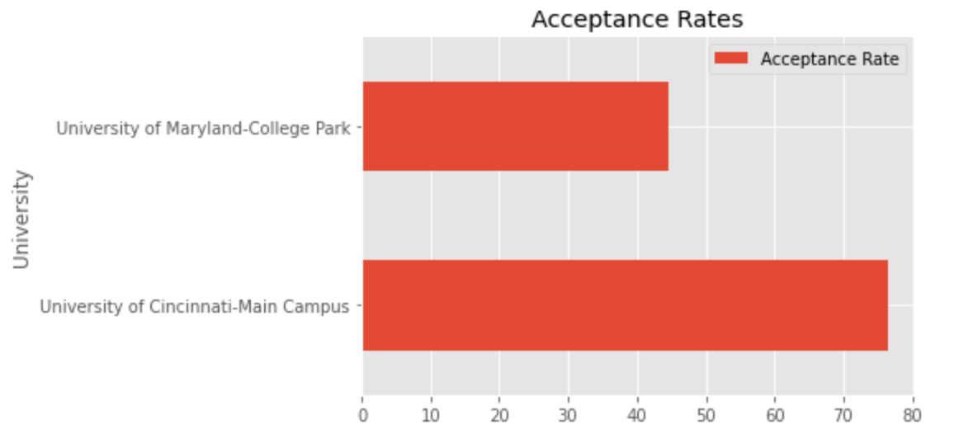

* 1. **Comparing Tuition**

Tuition is calculated on two separate occasions: in state and out of state depending on the location of the school. The data collected is based on in state tuition. Calculated in this total is additional fees such as room and board and books and supplies. Both Tuitions came out to similar values rounding to a total of $26,000 (UC - $25,769, UMD - $25,435).

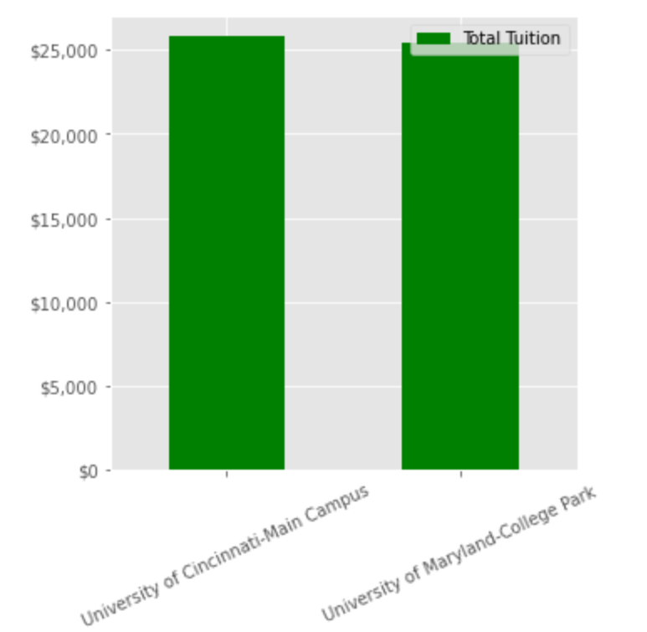

* 1. **Comparing Time to Complete**

Time to complete is based on how many people took the normal amount of time to complete their degree. 69% of students graduating from University of Maryland-College Park completed their program within 100% "normal time" (i.e. 4 years for a 4-year degree). Comparatively, 86% completed their degrees within 150% of the normal time, and 87% within 200%. 28% of students graduating from University of Cincinnati-Main Campus completed their program within 100% "normal time" (i.e. 4 years for a 4-year degree). Comparatively, 65% completed their degrees within 150% of the normal time, and 66% within 200%.

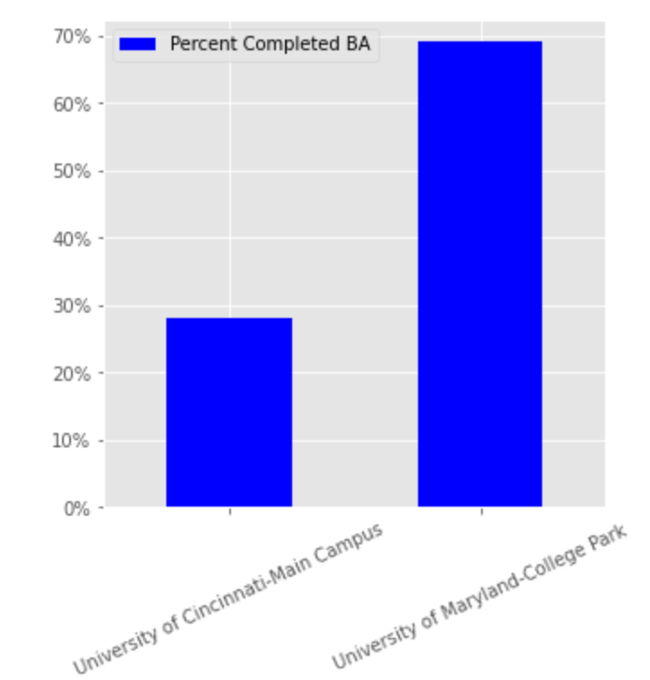

* 1. **Comparing Venues Nearby**

Each college campus has their own collection of restraturants, bars, coffee shops, bookstores, and other venues. Using data from the Foursquare API, I was able to gather certain venues around both campuses. The University of Cincinnati has 60 venues and the University of Maryland has 23 venues nearby. The most common venue at UC is a Sandwich Place and at UMD it is Fast Food Restaurants. As my favorite venue is Coffee Shops, I needed to evaluate the Coffee Shop data. As Coffee Shops are also sometimes called Café, I searched for both types. Returned is 3 Coffee Shops near UC with 0 Cafés and 1 Coffee Shop and 1 Café near UMD.

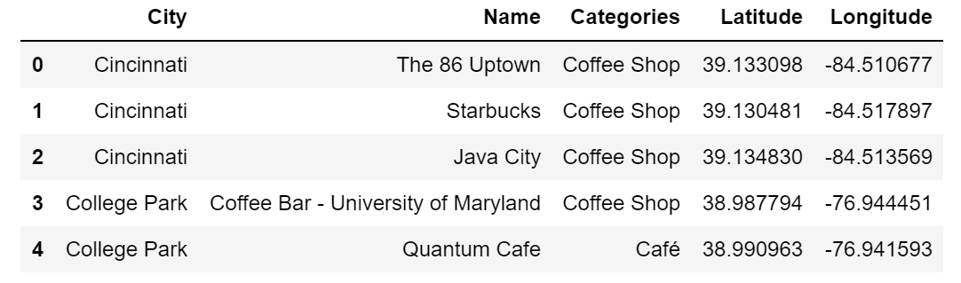

### **Results & Conclusion**

After analyzing all of the data, we can conclude that there are many factors when making a decision about college. Most of these factors include: majors available, cost, location, amenities, involvement, and overall feel. Academic rigor is also a big topic when deciding. My largest factors when deciding between schools were as follows: ranking of the specific program I intend to study, cost, location, academic rigor, and overall feel. From this study, I concluded that UMD has a lower acceptance rate, the price for in-state tuition is about the same, percent completion is higher at UMD, and there are about the same amount of coffee shops on both campuses.

Using the results as well as certain data has allowed me to conclude that I will attend the University of Maryland. The degree will be in Information Systems and will help me to advance my education while learning under some of the best professors in the industry. Being close to Washington D.C. will not only give me insight into living in a major city, but will expose me to companies in the area. My career goals are to graduate with a Master in Science and pursue a career in data science. Completing this course through IBM has allowed me to gain insight into a broad range of topics such as machine learning, artificial intelligence, as well as multiple ways to visualize data using python. After completing this specialization, I am able to take to my academic career, a better understanding of topics learned.